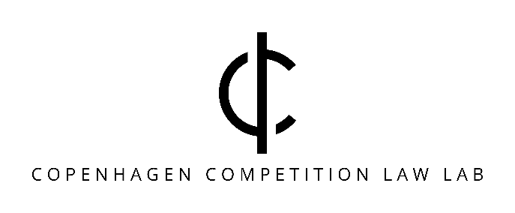
DRAFT

The Digital Markets Act: Two Years Later – Where Do We Stand?
Date: June 12, 2025.
Time: 9:00 AM–12:00 PM.
Location: Copenhagen Business School, Solbjerg Plads 3, SPs10 KPMG, and online.
Program:
9:00–9:05 | Welcome and Introduction | Kathrine Søs Jacobsen Cesko, Assistant Professor at Copenhagen Business School
9:05–9:50 | Session 1: The DMA - Legal Framework, Regulatory Approaches, and Gatekeeper Obligations  An in-depth look at the legal framework of the DMA, its relationship with other EU legislation, and the regulatory approaches shaping its enforcement. Key responsibilities and compliance challenges for gatekeepers will also be explored. | Professor MSO, Andrej Savin, CBS LAW
9:50-10:15 | Break with coffee and cake
10:15-11:00 | Session 2: DMA Compliance - Challenges and Credibility  Examining the role of compliance reports in the DMA's effectiveness, with a focus on their credibility and impact on stakeholders. This session will also discuss the decentralisation of enforcement under the DMA and its implications for compliance and accountability. | Dr. Alba Ribera Martínez, University Villanueva
11:00-11:45 | Session 3: Supporting the Enforcement of the DMA: The Role of National Competition Authorities  Insight into the supporting role played by the Danish Competition and Consumer Authority in the enforcement of the DMA. In addition, a seconded civil servant from the Danish Competition and Consumer Authority will present the first specification decisions adopted by the Commission on 19 March 2025. | Erik Dahlberg, Chief Special Advisor at the Danish Competition and Consumer Authority and Marie Gjørtler Mouritzen, Seconded National Expert to the European Commission, DG Connect
11:45-12:00 | Roundtable Discussion: The Future of the DMA – What is Next?  Open floor for questions and contributions from attendees. | Christian Bergqvist, Associate Professor at Copenhagen University

Registration:
Register here to attend: https://cbs.nemtilmeld.dk/1182/. Please indicate whether you will attend in person or online, and whether you would like a participation certificate.
Registration deadline: June 6, 2025.
Online attendance: You will receive a link to the event a few days in advance.
The event is organized by Copenhagen Competition Law Lab and hosted by CBS LAW.
Feel free to ask questions to the organisers:
- Christian Bergqvist, Associate Professor at Copenhagen University: cbe@jur.ku.dk
- Kathrine Søs Jacobsen Cesko, Assistant Professor at Copenhagen Business School: ksjc.bhl@cbs.dk

